The analysis and ideas of working in a multicultural environment

1. **Background**

Being one of the most prevailing and enormous cosmetics industries around the world, L’OREAL has produced thousands of products that meet a variety of requirements of customers with different age ranges. Although being affected by the war issue and the strict supervision of Chinese government, L’OREAL Group still profited strongly by 20.9% on reported figures.

La Roche-Posay, a branch brand of L’OREAL that created in 1975, ranking at TOP1 dermocosmetic brand worldwide, recommended by 90,000 professional dermatologists. (L'OREAL, n.d.) Their products cover the areas including face & body skin care, shower gel, shampoo etc., which meet the needs of not only female but also male, and they are also suitable for customers in all ages.

1. **Self-evaluation**

Having dreamt about working in a foreign country for a long time, I am quite interested in the job offer I found which is presented in the following web page: [Job Offer](https://careers.loreal.com/en_US/jobs/JobDetail/Japan-Business-Data-Analyst-Active-Cosmetics-Division-La-Roche-Posay/128785). This offer provides a job work as a business data analyst in the branch company of L’OREAL in Tokyo.

First and foremost, I am quite interested in numbers (data) and the correlations between them. I studied years in the area of data analytics, but normally I processed data for social or for human resource management areas. At present, I am studying the basics of marketing and applying them into reality to some extents. Thus, I really want to combine these two areas together, to implement all my knowledge in these two sections. Being a data analyst in a cosmetics company fits my requirements perfectly and that is why I pick up this offer.

As a Chinese, I choose to work in a French company which is located in the capital city of Japan, which is already really “multicultural”. As universally knows, Asian women care about their skins carefully and they always have the best skin. (Health Essentials, 2019) In this article, it says that Asian women will do at least five steps for their daily skin care. Therefore, working in Japan seems the best choice to study the users’ (Asian women’s) thoughts towards skin care and to help cosmetics company like L’OREAL to describe the portraits of customers.

It is not only because I am a loyal user of L’OREAL group’s products who have deeply used several products for over 10 years, but also, I am really interested in the culture and working atmosphere in both France and Japan. With an opportunity to work in a multicultural environment, I can get different aspects of ideas to questions and also suggestions to my immature and inefficient proposals.

Concerning the job description of this offer, I summarized five core soft skills and some possible hard skills required in this position.

Soft skills:

1. Communication, negotiation and expressive skills;
2. Data sensibility;
3. Summarize and writing skills;
4. Relationship and time management;
5. Language: English, French, Japanese;

Hard skills:

1. Data management;
2. Data Analytics tools (Python, BI, R, Excel etc.);
3. Marketing plan;
4. Business reports;

I consider myself can fit in this position because I have most of the skills that this position required and I have a strong self-learning ability, so I can swiftly adapt into the new environment and learn the knowledge and concepts related to the product itself and also job-related affairs.

The **biggest challenge** for me to perfectly play this role is the **language** (generally French and Japanese in this case) and also some professional terms in marketing sector. At this stage, the language problem always comes to be the first place because we cannot get involved in to a new culture if we cannot acquire the local language. Besides, in nearly all working circumstances, foreign (local) languages build up the bridge for communicating and task assignment.

1. **Cross cultural analysis**

3.1 Leadership analysis

In Japan, teamwork and organization are extremely important. This is mostly the same idea as it is in China. Japanese companies expect staffs to be honest and serious, these are the two main caracters being valued. (Link Japan Careers Inc., 2021)

As for the leadership, Japanese companies have a high expectation for leaders to be charismatic and a strong communicator. (Link Japan Careers Inc., 2021) Also, leaders always have a higher position inside or even outside of the company. So, to be modest in front of them and to show them enough politeness is really important.

On the other hand, because this is a job working in a French company. For French leaders, what is matter is using right titles. Addressing your superior by ‘Monsieur’ or ‘Madame’ seems necessary.

What is more, here comes an analysis which presents the styles of the dominant leadership of three countries (Japan, China and France). (Korn Ferry, 2014) As we can see in these data, Jpanese leaders care greatly about the participative while French leaders also think it is really significant.

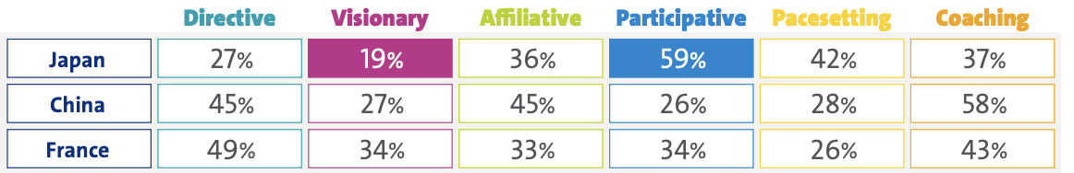

**Figure1 Dominant leadership styles by country**

3.2 Cross Cultural Management (CCM) analysis

**Hall’s 3D paradigm**

3.2.1 Hall’s paradigm - High Context Vs. Low context

Japan is generally considered as a high-context culture, there is a saying like: “If you don’t get the hidden meaning while Japanese people are talking, you might be considered KY (kuki yomenai), means you ‘cannot read the air’.” (Yoshino, 2022) To stay in Japan, we have to being aware of your own social status, reading behavioral signals and understanding the situation without words, sometimes you have to put yourself in others situation and think with other’s angel. Comparing to China, Japanese culture is more high-context and we should take more care about the conversation with Japanese.

In the same time, French society also being deemed has a high-context culture, people in France communicate formally and diplomatically. Verbal and non-verbal skills are both so important when communicating with French because we should not only listen what they say but also guess what are the hidden meaning by observing their facial expressions, tone, gestures and postures. (World Population Review, 2022)

**Solutions:**

Facing the problem living in a high-context cultrue, I have to pay more attention on choosing the right occation to speak properly. Besides, I should learn to be more polite when interact with colleagues, superiors especially Japanese people.

3.2.2 Hall’s paradigm – Interpersonal Distance

According to the research done by Chara Scroope, it was said that Japanese people highly need a personal space. When possiblem people will maintain distance from one another. In Japan, when we standing next to a friend, a family member or a colleague, people usually at arm’s length apart. This distance is further among acquaintances. Besides, without permission, it is prohibited to get into other’s office or other work place. Also, touch others object actively is also really impolite. (Scroope, 2021)

Compared to Chinese culture, Japanese people pursuit a more private space and they deem politeness as one of the most important things in daily life. Although Chinese people also care the privacy seriously, but Chinese culture have a relatively low need for terriory. People tend to stand closer and they also willing to share their space sometimes.

These images below presnt the reality for people in France, Japan and China when it comes to the situation of gathering together.(Figure 2 and 3) (EDWARD T HALL - High Context/Low Context Culture Clash in Diagrams, 2010) It can easily find that France and Japan people are willing to stay in clusters when in a party or ceremony while Chinese people perfer to stay together.

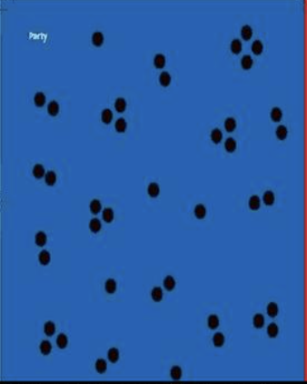

**Figure 2 Interpersonal Distance of France and Japan**



**Figure 3 Interpersonal Distance of China**

**Solutions:**

For this point, what is necessary is to respect others’ cultures and “do as romans do”. As a Chinese person working in two high interpersonal distance cultures, I must take huge attention to leave others with enough personal space and get permissions of others while touching anything that does not belong to me. To avoid making others being angry.

3.2.3 Hall’s paradigm - Polychronic Vs. Monochronic

As it said before, Japanese culture cares greatly about the politeness, apart from behave well in front of others, following the time seted strictly is also significant. However, Japanese working environment always filled with polychronic culture. It is ture that Japanese people care so much about being punctual, but unlike Germany culture, Japanese culture highlights people-oriented life and working attitude. Except for the deadline of big projects, agendas in Japanese companies are generally flexiable. (S, 2022) French culture also has a similar situation. However, this kind of culture may always exists a feature that people prefer doing multitask in the same time, which is considered as “Not focused” or “Dispersed” in monochronic countries like Germany and the U.S.. (Rochefort, 2021) Likewise, time is rather seen as flexible and fluid and respect is rather shown by having time for someone spontaneously.

**Solutions:**

Be ontime is absolutely a polite behaviour in whether which country around the world. However, in polychrninic countries (France, Japan and China in this case), being too strict on time could have some troubles. Think in flexibility about the time management and agenda is necessary.

**Hofstede’s 4D model**

During the year of 1965 and 1973, Geert Hofstede executed a large survey study regarding national values differences across the worldwide subsidiarires of IBM and he proposed a concept named Hofsted Cultural Dimensions Theory. It has four dimensions at first, they are: Individualism-collectivism, power distance, masculinity and feminity and uncertainty avoidance. It is until 2010, he extended the dimensions into six and did researches for 93 countries worldwide. (Wikipedia, 2022)

In this report, the dimensions in Hofstede’s model will be analyzed with the countries between France, Japan and China. The figure below illustrates the scores these three countries got in Hofstede’s study in the first four main dimensions. (Hofsted)

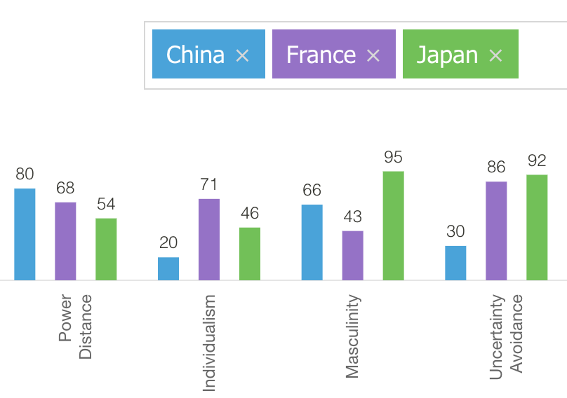

**Figure 4 Four main dimensions of Hofstede’s model for three countries**

3.2.4 Hofstede’s model - Individualism and Collectivism

Japan is considered to be a collectivistic country, but not very strong. According to Moran, Japanese culture is more into group leadership than individual initiative. That means that a leader from an individual country like France in this case needs to adapt to motivate employees in Japan by using group rewards and group work in order to be a successful leader. (ecm5336, 2018)

This circumstance is similar in Chinese culture while it is more collectivism-based. Chinese companies are more caring about the group harmony and the so-called “face” is extremely important, this is relatively the same in Japan, people do not critized the others directly in public, which will lead to the result of “ Losing face” of other people.

**Solutions:**

Working with a French leader (probably), I have to get used to their habits to figure out mistakes in the front of colleagues. In the same time, I have to pay attention to leave enough “face” for Japanese workmates and sometimes Japanese superiors.

3.2.5 Hofstede’s model - Power distance

Being associated with the dimension of individualism and collectivism and power distance, I found that French culture get both really high scores in these two dimensions. The kids are raised to be emotionally dependent first on their parents and then teachers and later their superiors. (Hofsted) So like Chinese and Japan, inequality in working place is acceptable in French culture.

Working in Japanese culture or French culture is similar in this dimension, I have to respect the decision made by superiors and sometimes he counts for 100%. In other words, nearly all the decisions must be accepted by your superiors. (Merhazion, Japan: High-Context Communication Style, 2020)(sometimes even not only your direct leader)

**Solutions:**

French working environment might courage staffs to be more individual and sometimes task-oriented, but they also have a clear hierachy in working places. In this area, Japanese and Chinese cultures are similar. So be awared of not to be too dependent on superiors while give them enough respect.

3.2.6 Hofstede’s model - Masculinity and feminity

Having extremely high score in masculinity and feminity evaluation, this is definitely one of the reason making Japan as a strong and develped country. This culture displays masculinity generally by working pretty hard for contributing to the company and also to their family. What is more, Japanese people are more decisive and their behaviours are more strict and tough than French and Chinese people especially in men. So, under this kind of social background, people are forced to be proacive and competitive. (Waramit Charoensook, Sasina Chomsuwan, Apisara Ketnute, Natwara Kamolrungwarakul, 2014)

French culture is more tend to the feminity, they can have a balance of working hours and holidays, which is gererally 35 working hours per week and arount 5 weeks holiday per year. (Marcello Estevão, Filipa Sá, 2008)

So although this job will work in Japan, but it is a French company, which might balance the time for working between 35 hours and 40 hours per week. But this is not a problem for a Chinese people because as a society that more tend to masculinity, working in a Chinese company will have an extra working time frequently.

**Solutions:**

Be less competitive than it is in China, but I still have to work hard to finish tasks on time and with high quality. A big differece between Chinese and French culture in this aspect is that in French culture, male and female are equal while it is not really in Chinese culture. I have to avoid behaving any kind of bias according to different gender.

3.2.7 Hofstede’s model – Uncertainty avoidance

We call the degree of uncertainty avoidance as “Uncertainty Avoidance Index” (UAI) in Hofstede’s model.

In this part, both France and Japan presnt a really high score of uncertianty avoidance. For them, they can hardly tolerate uncertain and ambiguous situations and future. Their life is well-structured depends on rules, regulations and laws that the society set up. (French social and business culture, 2014) Otherwise, French and Japanaese partner can feel a strong anxiety and the business-relationship will be damaged. (Boonkanit Rattanakoson, Supanart Kijpaitoon, Boonyanuch Tirapanichayakul)

On the other hand, Chinese culture is viewed favourably at a time of crisis and uncertainty because it indicates that people can coexist with uncertainty and tend to be more flexible, adaptable and entrepreneurial. A lot of so called “rules” are not marked clearly and you have to ask people in charge actively unless you will make mistakes on that.

**Solutions:**

Rules seems much more important in these two foreign cultures than in China, so to stick on cleared rules is necessary and in order not to make troubles on these things, comprehending all the rules and laws should be placed at the first place than any other things. Besides, be honest and well-planned when interact with French or Japanese colleagues and superiors.

1. **Conclusion**

Working in a multicultral environment should be a tough thing, we should not only overcome the stereotypes of a different country, but also try our best to adapt into an atmosphere with multiple kinds of ideas, thinking patterns, cultural behaviours etc.. None of the changes is easy to adpat with. So after doing researches and wrting this report, I mostly find out the similarities and differences, the can dos and cannot dos and the communication tactics when I will work in another country, in a brand-new working environment.

Apart from the hard skills, soft skills that are required by the job position itself, jumping out of my personal comfort zone and overcoming a new culture in reality counts more in my perspective.

# Bibliography

Boonkanit Rattanakoson, Supanart Kijpaitoon , Boonyanuch Tirapanichayakul. (2014). French social and business culture. *French Social*. Retrieved from Cultural Differences: https://sites.google.com/site/crossculturemnp/introduction-3

Boonkanit Rattanakoson, Supanart Kijpaitoon, Boonyanuch Tirapanichayakul. (n.d.). *France VS. Thailand - Business Communication 1:Final Project.* Retrieved from Cultural Difference: https://sites.google.com/site/crossculturemnp/introduction-3

ecm5336. (2018, 11 04). *Japan’s View on Individualism, Culture, and Personal Relationships*. Retrieved from PennState: https://sites.psu.edu/global/2018/11/04/4908/

*EDWARD T HALL - High Context/Low Context Culture Clash in Diagrams*. (2010, 8 5). Retrieved from https://americanepali.wordpress.com/tag/edward-t-hall/

French social and business culture. (2014). *French Social*.

Health Essentials. (2019, 11 16). *Here is why Asian Women have the best skin | Skincare Routine of Asian Women*. Retrieved from Health Essentials: https://healthessentials.com.sg/blog-headlines/blogart84

Hofsted, G. (n.d.). *Country Comparison - Hofstede Insights.* Retrieved from Hofstede Insights: https://www.hofstede-insights.com/country-comparison/china,france,japan/

Korn Ferry. (2014). *Leadership research paper.* Tokyo: Korn Ferry.

Link Japan Careers Inc. (2021, 3 17). *Management & Leadership in Japan: What to Expect at Work*. Retrieved from Link Japan Careers Inc.: https://linkjapancareers.net/management-leadership-in-japan-what-to-expect-at-work/#:~:text=How%20is%20leadership%20in%20Japan,keep%20peace%20amongst%20your%20staff.

L'OREAL. (n.d.). *L'OREAL*. Retrieved from La Riche-Posay - L'Oréal Group: https://www.loreal.com/en/active-cosmetics-division/la-roche-posay/

Marcello Estevão, Filipa Sá. (2008). The 35-hour workweek in France: Straightjacket or welfare improvement? *Economic Policy*.

Merhazion, A. (2020, 4 18). *Japan: High-Context Communication Style*. Retrieved from PennState: Japan: High-Context Communication Style

Merhazion, A. (n.d.). *Japan: High-Context Communication Style*.

Rochefort, P. (2021, 12 1). *Intercultural management - French work ethics*. Retrieved from Intercultural management: http://www.understandfrance.org/Business/Intercultural3.html

S, R. (2022, 1 26). *Monochronic vs Polychronic Cultures: Difficulties Europeans May Face When Working with Japanese People*. Retrieved from Career Management: https://career-management.de/en/blog/polychronic-vs-monochronic-cultures-2/2608/

Scroope, C. (2021). *Japanese Culture - Communication - Culture Atlas*. Retrieved from Culture Atlas: https://culturalatlas.sbs.com.au/japanese-culture/japanese-culture-communication

Waramit Charoensook, Sasina Chomsuwan, Apisara Ketnute, Natwara Kamolrungwarakul. (2014). *Cross Cultural: Thailand and Japan.* ICBC 201 Business Communication I.

Wikipedia. (2022, 9 28). *Hofstede's cultural dimensions theory*. Retrieved from Wikipedia: https://en.wikipedia.org/wiki/Hofstede%27s_cultural_dimensions_theory#:~:text=The%20original%20theory%20proposed%20four,orientation%20versus%20person%2Dorientation).

World Population Review. (2022). *High Context Countries 2022*. Retrieved from World Population Review: https://worldpopulationreview.com/country-rankings/high-context-countries

Yoshino, K. (2022, 8 26). *How to Live Happily Ever After in Japan’s High-Context Culture*. Retrieved from GLOBIS INSIGHTS: https://globisinsights.com/career-skills/communication/high-context-culture-japan/#:~:text=Japan%20is%20generally%20considered%20a,everyone%20on%20the%20same%20page.